While there are steps you can take to temporarily fix or alleviate discomfort and prevent additional damage, your orthodontist should always be notified. Contact them if you have any concerns during this time. Many times, they may be able to handle the

issue over the phone or virtually through video communication.
Tools + supplies:
Orthodontic relief wax
Dental floss
Disinfected tweezers
Q-tips
Salt

Lost o-ring
An o-ring is the tiny rubber band or sometimes a very thin wire (ligature), that holds the orthodontic wire in the bracket/brace. If rubber ligature should come off, you may be able to put it back in place using disinfected tweezers. If a wire ligature comes loose, simply remove it with the tweezers. If the wire ligature is sticking out into the lip but is not loose, it may be bent back down with a Q-tip or pencil eraser to eliminate the irritation. Should this happen, be sure to notify your orthodontist and come up with a plan for repair. Note: selfligating brackets don’t use o-rings.

Protruding wire
Occasionally, the end of a wire will work itself out of place and can irritate the mouth. Use a Q-tip or clean tweezers and try to push the wire so that it is flat against the tooth. If the wire cannot be moved into a comfortable position, cover it with relief wax. Should changes with your wires occur during this time be sure to contact your orthodontist to make them aware of the issue.

Irritation in mouth
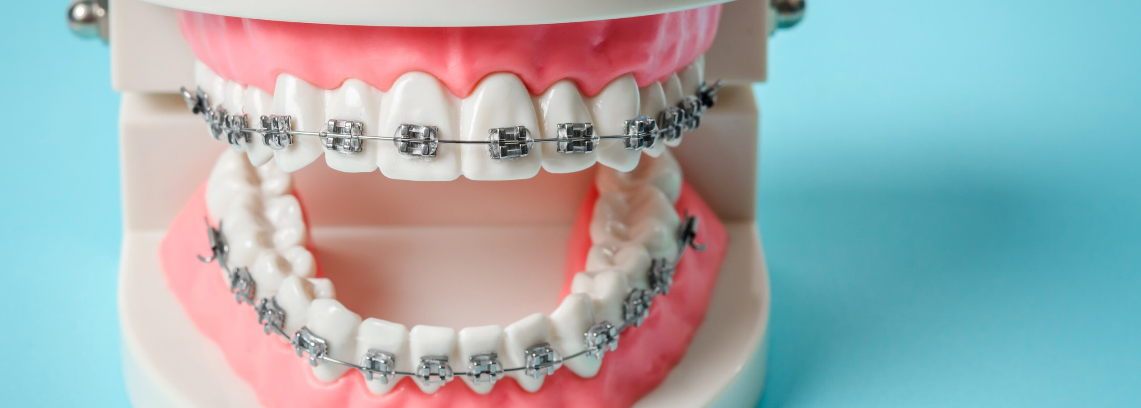
Sometimes braces or wires can be irritating to the mouth, especially when eating. A small amount of orthodontic relief wax makes an excellent buffer between metal and mouth. Simply pinch off a small piece and roll it into a ball the size of a small pea. Flatten the ball and place it completely over the area of the braces causing irritation. Wax can be purchased at any drug store if you are unable to get some from your orthodontist during this time.
HANDLING

ORTHODONTIC

ISSUES

AT

HOME
:
rubber

band
hooks
archwire
brackets
o
-
ring
Interproximal brush
Toothpicks
Non-prescription pain reliever (acetaminophen or ibuprofen)
Topical Anesthetic (Orabase or Ora-Gel)

Discomfort
It’s normal to have some discomfort during orthodontic treatment as your teeth move, however it should not last longer than a couple days. Rinsing your mouth with warm salt water and taking over-the-counter pain relievers, such as acetaminophen or ibuprofen, may alleviate some discomfort. If the discomfort lasts longer than a couple days be sure to call your orthodontist to discuss.

Mouth sores
Some patients are susceptible to episodes of mouth sores. While braces do not cause them, they may be precipitated or exacerbated by an irritation from braces. One or several areas of ulceration of the cheeks, lips or tongue may appear. This is not an emergency but may be very uncomfortable. Prompt relief may be achieved by applying a small amount of topical anesthetic (such as Orabase or Ora-Gel) directly to the ulcerated surface using a cotton swab - reapply as needed. If after a couple days the discomfort does not resolve, call your orthodontist to discuss.

Loose braces or bands
If the braces or bands have come loose in any way, call your orthodontist to determine appropriate next steps.

Learn more: aaoinfo.org/blog
Copyright © 2020, American Association of Orthodontists. All rights reserved.

